**📊 Marketing Campaign Performance Dashboard**

# 1.Overview :

This project is an **interactive dashboard** that analyzes marketing campaigns to assess their effectiveness. The goal is to help businesses make **data-driven decisions** by evaluating KPIs, comparing channels, understanding audience demographics, and identifying seasonal performance trends.

# --------------------------------------------------------------------------------------------------------------------------------------

# 2.Tech :

* **Python (Pandas, NumPy) → Data cleaning & analysis.**
* **Matplotlib & Seaborn → Visualizations inside Jupyter Notebook.**
* **Streamlit → Interactive dashboard for end users.**
* **Excel → Original dataset storage.**

# -------------------------------------------------------------------

# 3.Objectives :

**-**Measure the success of marketing campaigns using key metrics (CTR, CPC, CPA, ROAS).

------------------------------------------------------------------

**-**Compare performance across marketing channels to optimize budget allocation.

------------------------------------------------------------------

**-**Analyze demographic data (age, gender, location) to identify high- and low-performing segments.

------------------------------------------------------------------

**-**Detect seasonal or time-based trends in campaign performance.

------------------------------------------------------------------

**-**Provide clear visualizations and recommendations for future marketing strategies.

# --------------------------------------------------------------------------------------------------------------------------------------

# 4.Dataset :

**+Campaign Information**: ID, name, start/end dates

**+Campaign Names**: Wishlist Wonders, Cart to Couch, Deal of the Day, Flash Sale Frenzy, Shop & Share, Seasonal Steals

**+Performance Metrics**: impressions, clicks, conversions, spend, revenue.

**+Channel Details**: social media, Email, Paid-ads, Influencer Marketing.

**+Demographics**: Age group, Gender, Location of targeted users.

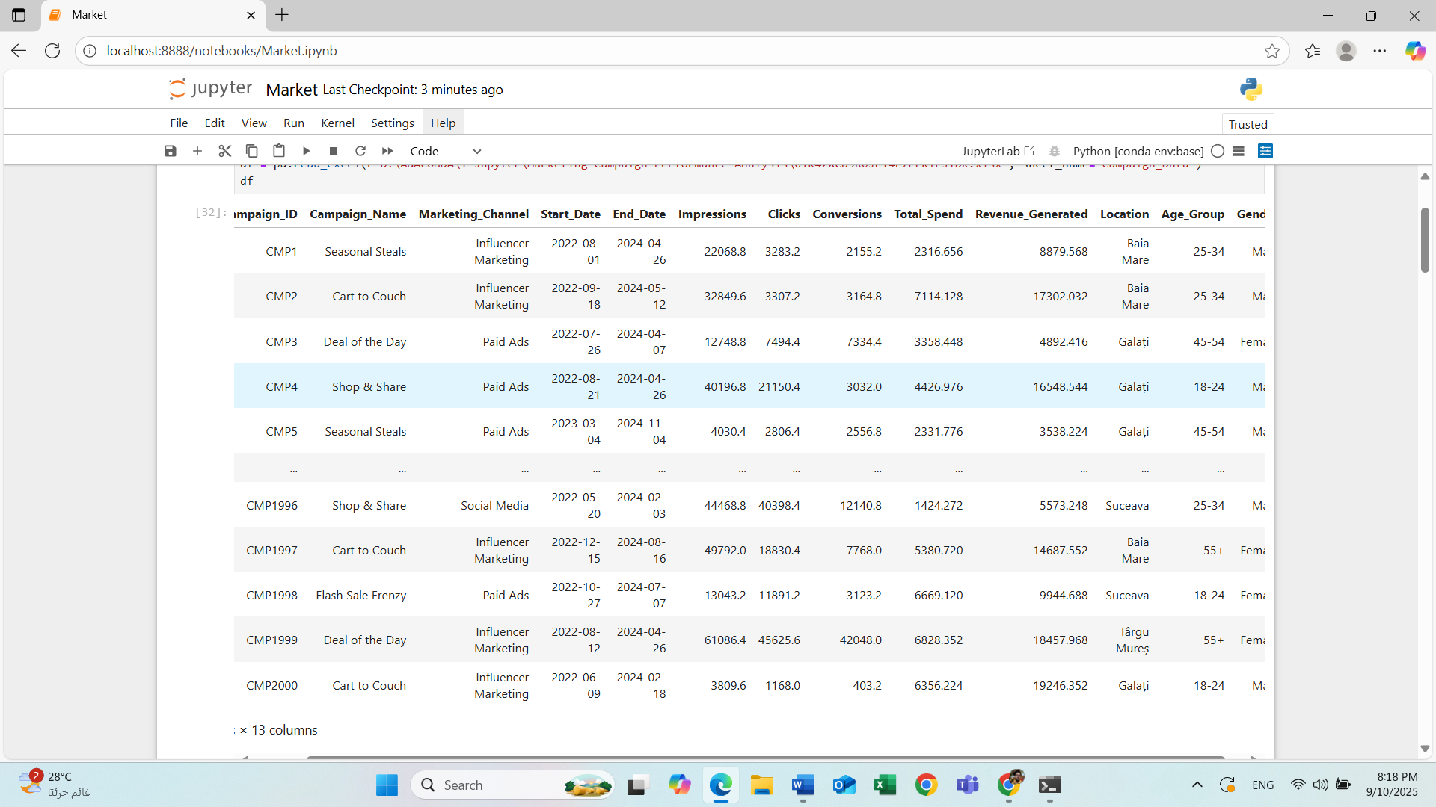

# -Dataset After Adding Columns :

# 5.Key Features:

**✅ KPI Summary – Displays total impressions, clicks, conversions, spend, revenue, average CTR, and overall ROAS.  
✅ Campaign Comparison – Bar/line charts showing CTR, conversion rate, and ROAS across campaigns.  
✅ Channel Performance – Pie/bar charts illustrating budget distribution and ROAS by channel.  
✅ Demographic Insights – Conversions and revenue breakdown by age, gender, and location.  
✅ Time-based Trends – Line charts monitoring performance over weeks/months to highlight seasonal peaks.**

# --------------------------------------------------------------------------------------------------------------------------------------

**📌 Top-performing campaigns & channels: Identify campaigns with highest ROAS and conversion rates.  
📌 Budget optimization: Highlight channels with high cost but low ROAS for budget reallocation.  
📌 Demographic responsiveness: Understand which audience segments engage best.  
📌 Seasonal patterns: Detect times of the year with peak conversions.**